Project Design Phase-II

Data Flow Diagram & User Stories

|  |  |
| --- | --- |
| Date | 14 October 2022 |
| Team ID | PNT2022TMID07004 |
| Project Name | Project - AI-Based localization and  classification of skin disease with erythema |
| Maximum Marks | 4 Marks |

# Data Flow Diagrams:

A Data Flow Diagram (DFD) is a traditional visual representation of the information flows within a system. A neat and clear DFD can depict the right amount of the system requirement graphically. It shows how data enters and leaves the system, what changes the information, and where data is stored.

# DFD:

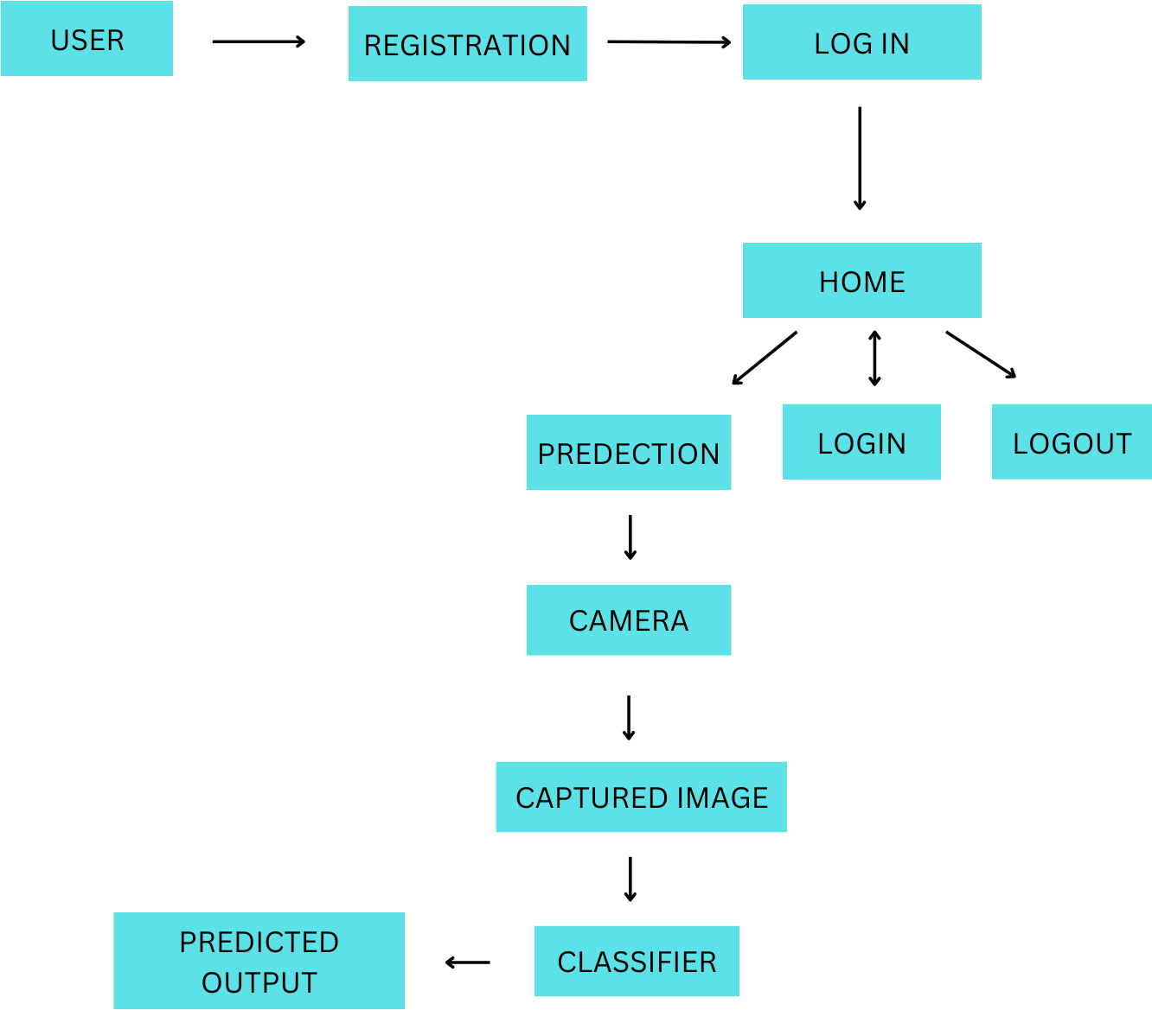

**User Stories**

Use the below template to list all the user stories for the product.

|  |  |  |  |  |  |  |
| --- | --- | --- | --- | --- | --- | --- |
| **User Type** | **Functional Requiremen t (Epic)** | **User Story Number** | **User Story / Task** | **Acceptance criteria** | **Priority** | **Release** |
| Customer (Mobile user) | Registration | USN-1 | As a user, I can register for the application by entering my email, password, and confirming my  password. | I can access my account / dashboard | High | Sprint-1 |
|  |  | USN-2 | As a user, I will receive confirmation email once I have registered for the application | I can receive confirmation email & click confirm | High | Sprint-1 |
|  |  | USN-3 | As a user, I can register for the application through Facebook | I can register & access the dashboard with  Facebook Login | Low | Sprint-2 |
|  |  | USN-4 | As a user, I can register for the application through Gmail |  | Medium | Sprint-1 |
|  | Login | USN-5 | As a user, I can log into the application by entering email &  password |  | High | Sprint-1 |
|  | Dashboard | USN-5 | As a user ,I can access my dashboard. |  | Medium | Sprint-3 |
| Customer (Web user) | Registration | USN-1 | As a user ,I can register for the application by entering my email,password ,and confirming  my password. | I can access my account/dashboard | High | Sprint-4 |
| Customer Care Executive | Solution | USN-5 | Responding to each email you receive can make a lasting impression on customers. | Offer a solution for how your company can improve the customer’s experience. | High | Sprint-3 |
| Administrat  or | Manage | USN-5 | D0-it-yourself service for  delivering everything. | Set of predefined  requirements that must be met to make a user story complete. | High | Sprint-4 |